Please note – in order for virtual backgrounds to work properly on Zoom without a green screen, certain version and processor requirements must be met. Check
Zoom requirements here.

Zoom
From the website:
- Once signed in, navigate to Settings
- Under the Meeting tab, click on In Meeting (Advanced)
- Ensure the Virtual Background option is toggled to On

- Click Manage Virtual Backgrounds. A new window will open where you can drag and drop the background image file or upload the file from your computer.

From the desktop app:
- Once signed in, navigate to Settings
- Click on Backgrounds & Filters
- In the Virtual Backgrounds tab, click on the + to add the background image file
- Click Add Image to open a file browser window, then select the image file to upload
- Once uploaded, click on the background image in the Zoom app to set it as your background.

During a meeting:
- Click on Preferences from the Zoom menu
- Navigate to Backgrounds & Filters
- In the Virtual Backgrounds tab, click on the + to add the background image file
- Click Add Image to open a file browser window, then select the image file to upload
- Once uploaded, click on the background image in the Zoom app to set it as your background.

Google Meet
- Click on More Options next to the share screen button
- Click on Apply VIsual Effects
- Upload a background image by clicking on the image button
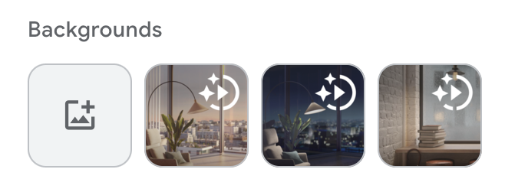
- The uploaded image will automatically set as your background.

